Ideation Phase
Empathize & Discover

Date | 30 September 2026
Team ID | SWTID-2026-8886
Project Name | Implement Client Script and UI Policy for Incident
Maximum Marks | 4 Marks

Empathy Map Canvas:
An empathy map is a simple, easy-to-digest visual that captures knowledge about a user’s behaviours and attitudes.

It is a useful tool to helps teams better understand their users.
Creating an effective solution requires understanding the true problem and the person who is experiencing it. The exercise of creating the map helps participants consider things from the user’s perspective along with his or her goals and challenges.
Example:
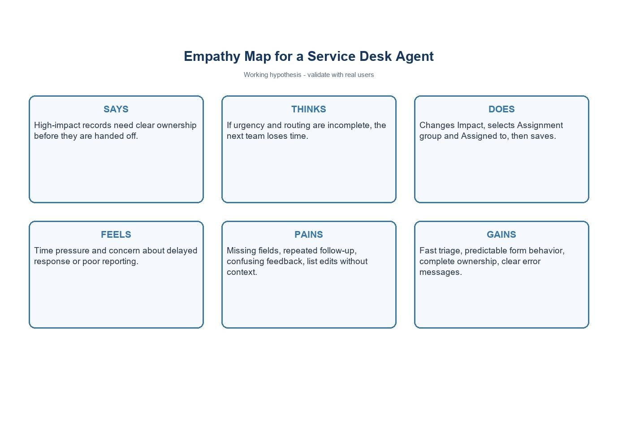

Reference: https://www.mural.co/templates/empathy-map-canvas

Project example: High-impact Incident triage by a service desk agent.
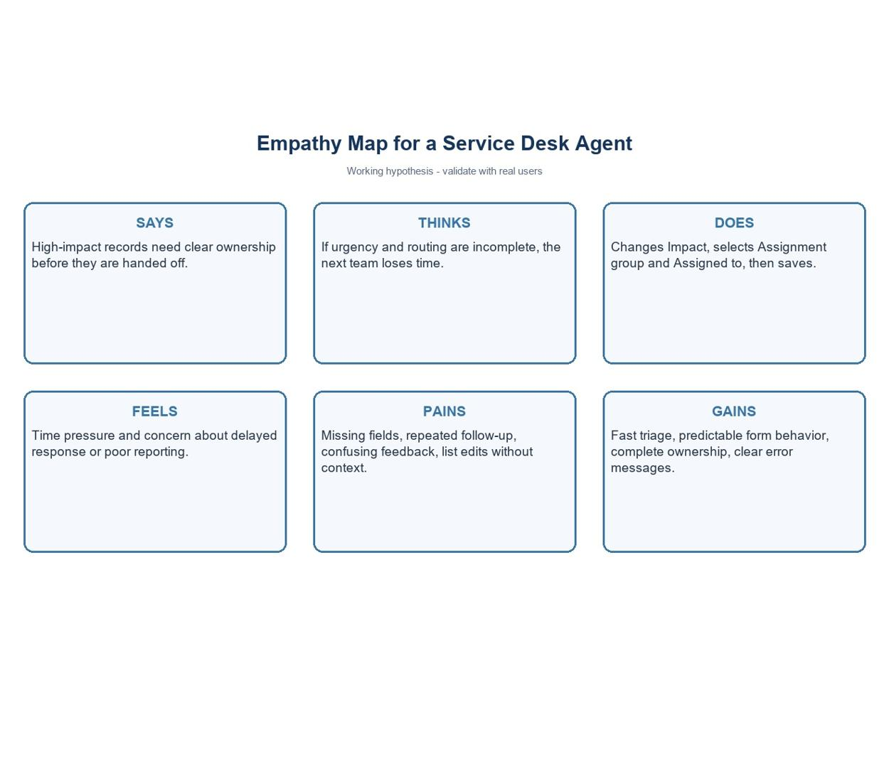
Empathy area | Incident triage observation
Says | High-impact Incidents need clear ownership before handoff.
Thinks | Incomplete urgency or routing slows the next team.
Does | Sets Impact, assigns group and person, then saves.
Feels | Under time pressure and concerned about delayed response.
Pains | Missing fields, follow-up, unclear feedback, list edits without context.
Gains | Fast triage, clear controls, complete record, understandable messages.
Project note: values use the standard Incident choices where Impact 1 and Urgency 1 represent High. Confirm field names and values in the target instance.

